

**Create a IBM Watson IOT platform and device**



|  |  |
| --- | --- |
| **Team ID** | **PNT2022TMID33576** |
| **Project Name** | **Smart waste management system for**  **metropolitan cities** |

Step 1: login into IBM CLOUD account

Step2: click on catalog and search for IOT platform

Step 3: Then search for IOT Watson platform then click on create

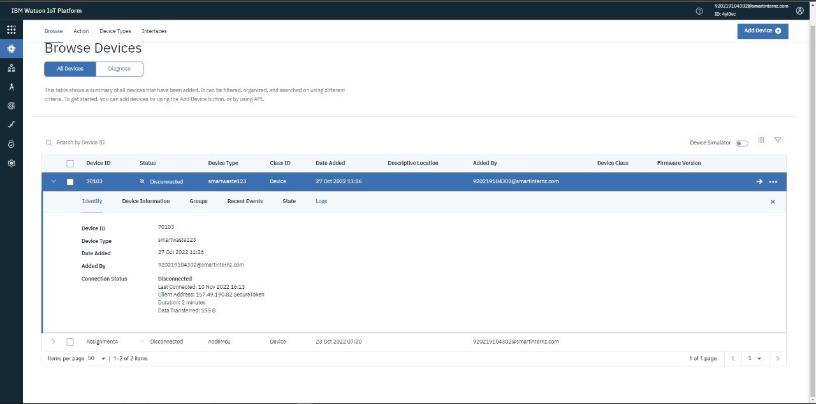

Step 4: Then click on add device and give the device type and necessary details then click finish Step 5: Finally, IOT Watson platform is successfully created

**Screenshots of IBM Watson IOT platform and device:**

